[](https://baike.so.com/doc/javascript:;)

[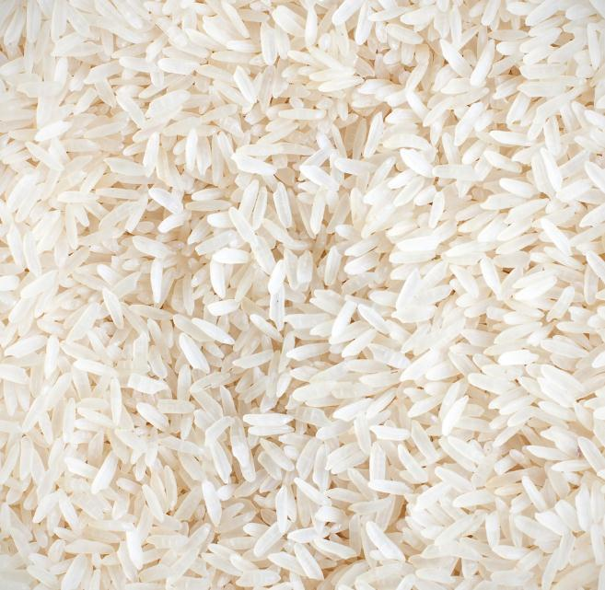](https://baike.so.com/doc/javascript:;)

[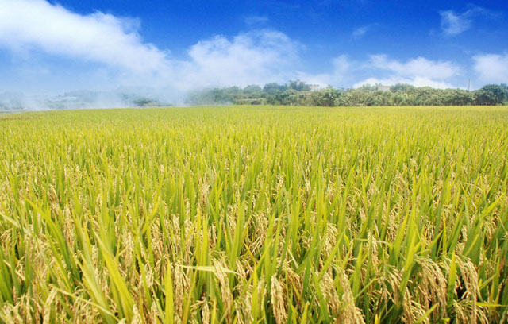](http://gxaml.cn.qiyeku.com/productshow-42171144.html)

[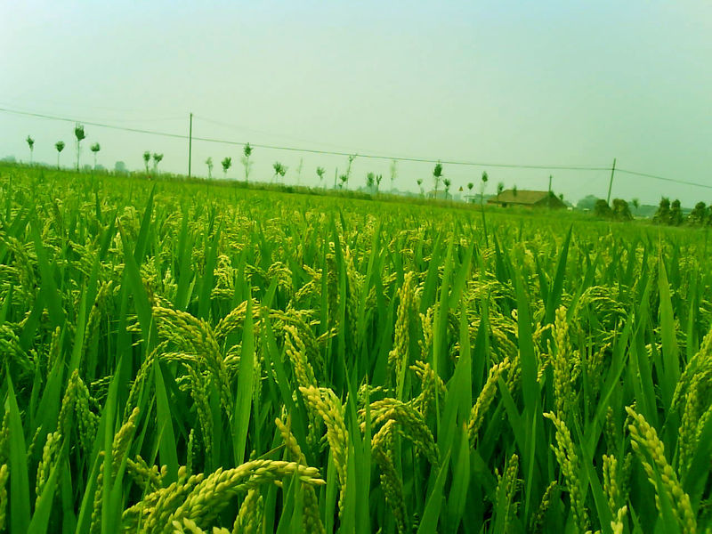](http://tupian.hudong.com/a4_01_33_01300000178518123892335938982_jpg.html)

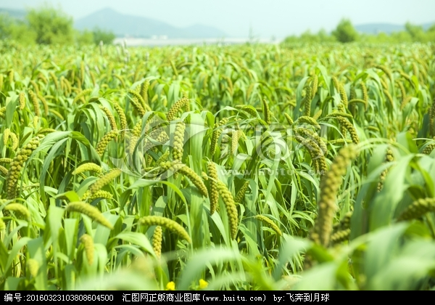

[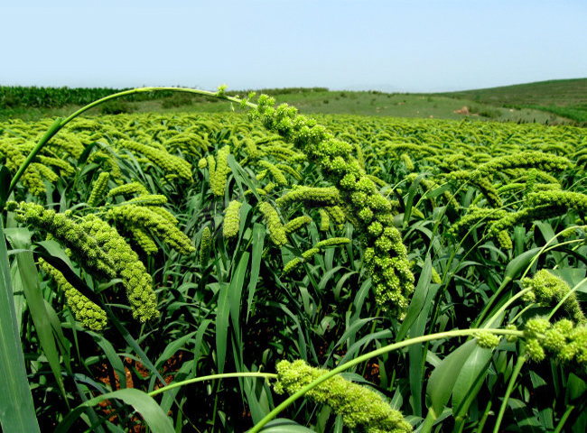](https://baike.so.com/doc/javascript:;)

[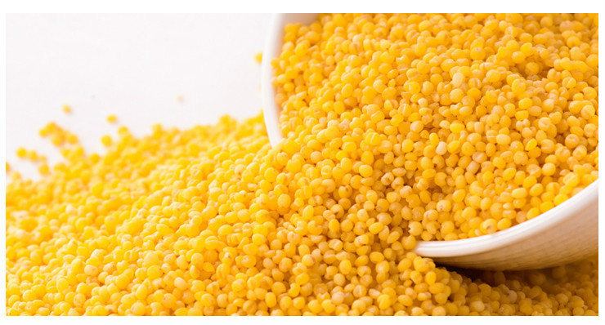](https://baike.so.com/doc/javascript:;)

[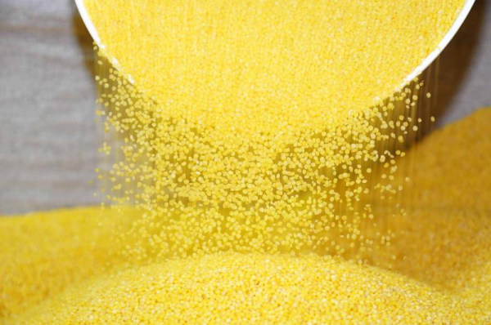](http://spro.so.com/searchthrow/api/midpage/throw?ls=s112c46189d%26lm_extend=ctype:3%26ctype=3%26q=%E5%B0%8F%E7%B1%B3%E5%9B%BE%E7%89%87%E5%A4%A7%E5%85%A8%26rurl=http:/www.meilishuo.com/share/907827244%26img=http:/d06.res.meilishuo.net/picdetail/a/7b/d2/1443849e2ee111cf043e1687cdb4_800_531_1_1.jpeg%26key=t0169b41fe4fc31ea92.jpg%26s=1551337513473)

